Behavior Scorecards – Probability of Default

_____________________________________________________________________________________________

|  |  |
| --- | --- |
| Developed for: | CEO, CFO, Risk Control, Accountants |
| Level: | Confidential |
| Document Owner: | Chief Financial Officer / Chief Credit Officer |
| Created: | December 2023 |
| Regulation: | IFRS9 – Accounting standard.  EBA GL 2017 06 – EBA guidelines on implementing IFRS9 in credit institutions |

|  |  |  |  |
| --- | --- | --- | --- |
| Version | Creator | Date | Description |
| 1.0 | Data Scientist | December 2023 | Document Creation |

Table of Contents

1. Definitions & Shortages 5

2. Introduction and Background 6

3.Algorithms 7

3.1.1 Logistic Regression 7

3.1.2 Decision Tree 8

3.1.3 Random Forrest 8

3.1.4 Gradient Boosting 9

3.2 Hyperparameter Tunning 10

4. Evaluation Metrics 10

4.1 Evolution Metrics – Hyperparameter Tunning 11

Admission Scorecard 12

5. Data 12

5.1 Sources 12

5.2 Data Selection: Co - Applicant 12

5.3 Target Feature 13

5.4 Time Selection – data splits 13

5.5 Balancing 13

6. Feature Selection 13

Top Features - Histograms 15

7. Model Selection 16

8. Results 17

7.1 Results Summary 18

[8. Selection of model continued – variables 19](https://nystartfinansab-my.sharepoint.com/personal/andreas_nilsson_nstart_com/Documents/Skrivbordet/Repository%20Homes/Data-PD-Modelling/Documentation/PD%20ScoreCards%202023%20.docx#_Toc155626244)

9. Calibration 20

10. Risk Grouping 22

Behavior Scorecard 23

11. Data – BSC 23

11.1 Source 23

11.2 Target Feature 23

11.3 Feature Importance 23

12. Model Selection – BSC 24

13. Results – BSC 26

14. Calibration – BSC 27

15. Features - BHC 28

16. Staging & Significant Increase in Credit Risk 28

# Definitions & Shortages

|  |  |
| --- | --- |
| Term | Description |
| **IFRS 9** | Regulations containing principles for the classification and valuation of financial assets and liabilities, as well as provisions and write-downs of credit losses. |
| ECL – Expected credit loss | Expected credit loss (ECL) is an estimate of potential losses on loans and financial assets due to borrower defaults or payment shortfalls, used for accounting and risk assessment. |
| EAD - Exposure at default | Exposure at Default (EAD) is the amount of exposure or financial risk associated with a borrower or counterparty at the moment of default. |
| PV – Present Value | Present value monthly is the calculation of the current value of future cash flows, factoring in monthly interest rates. It helps determine the worth of future money in today's terms. |
| CR – Cure Rate | The "cure rate" refers to the percentage of defaulted loans or assets that return to a performing or non-default status, resulting in successful recoveries. It essentially measures the effectiveness of the efforts to bring defaulted loans or assets back to a healthy and performing state. |
| LGD - Loss Given Default | Loss Given Default (LGD) quantifies the expected financial loss in the event of a borrower's default on a loan, expressed as a percentage of the outstanding debt that cannot be recovered. |

# Introduction and Background

The previous scorecards at Nstart were developed for IFRS9 legislation reservation and not optimized for the purpose of qualitative credit scoring. Due to significant increase in credit losses relative to early years of the company decision has been taken to develop new scorecards developed after more recent data.

In this development different combinations of sampling, scaling, feature, hyperparameter tunning and algorithms has been tested. The results show significant improvements in both the admission & behaviors score cards.

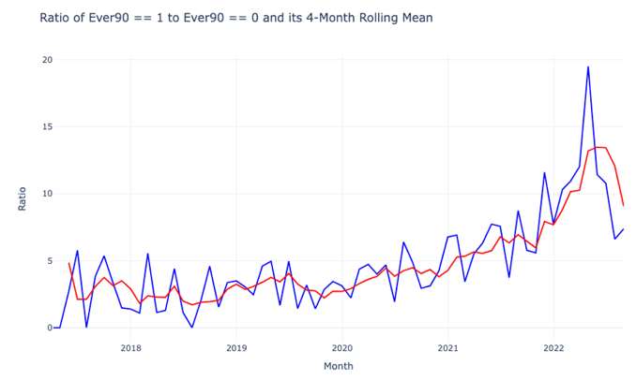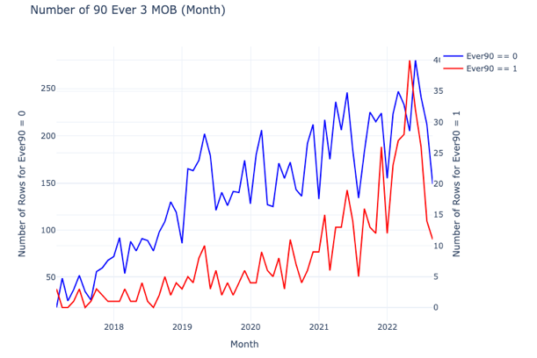

*Plot showing show 12 month losses has increased over time*

# 3.Algorithms

Non-linearity, with its ability to capture intricate relationships and patterns in data that linear models cannot, underscores the importance of experimenting with various machine learning models. Embracing this diversity ensures that we can effectively tackle the complex and dynamic nature of real-world data, leading to improved model performance, robustness, and problem-specific solutions. Therefore, a number of different models will be applied and not only the traditional within banking which is to apply Logistic Regression.

# 3.1.1 Logistic Regression

Nature:

LG (Logistic Regression) is a supervised learning algorithm primarily employed for binary classification tasks.

Model Function:

Its core function is to utilize a logistic or sigmoid function to predict the probability that a given instance belongs to a specific class. The probability (P(Y=1|X)) of a particular class label being 1, given the input features (X), is calculated using the logistic function. This function depends on model parameters (β0, β1, …, βn) which are adjusted iteratively during the training process.

Objective:

The primary objective of LG is to optimize these parameters to maximize the Log-likelihood across all observations, essentially making the observed outcomes most probable according to the model. The Log-Likelihood serves as a measure of the model's predictive accuracy, and the optimization process aims to maximize it.

Estimation:

Parameter estimation typically employs Maximum Likelihood Estimation (MLE), adjusting the model parameters to make the observed outcomes most probable based on the model's predictions.

Output:

In practice, LG provides a probability score for each observation, allowing for classification by applying a threshold (commonly 0.5) to categorize instances into one of the two classes.

Assumption:

An underlying assumption of LG is that there exists a linear relationship between the log-odds of the outcome and the predictor variables, making it a powerful tool for a wide range of classification tasks.

# 3.1.2 Decision Tree

Nature:

Decision Trees (DT) are versatile supervised learning algorithms used for both regression and classification tasks.

Model Function:

DTs are represented as tree-like structures where each node represents a feature, each branch represents a decision rule, and each leaf represents an outcome. Decision-making in DTs involves splitting data based on feature values and selecting thresholds to maximize information gain (classification) or minimize impurity (classification and regression).

Advantages:

Transparency: DTs are easy to understand and interpret, making them suitable for explaining model predictions.

Minimal Data Preprocessing: They require little data preprocessing, handling both numerical and categorical data with ease.

Drawbacks:

Overfitting: DTs can overfit, particularly on small datasets or with deep trees, leading to poor generalization.

Bias with Imbalanced Data: DTs can be biased when dealing with imbalanced datasets, favoring the majority class.

Structural Variability: Small changes in input data can result in significant structural variations in DTs, reducing their robustness.

# 3.1.3 Random Forrest

Nature:

Random Forest (RF) is an ensemble learning algorithm that combines multiple decision trees to address classification and regression tasks.

Model Function:

RF aggregates predictions from a collection of decision trees. Each tree is trained on a different random subset of the data and features, and predictions are made by averaging (for regression) or voting (for classification) across the individual trees.

Advantages:

Improved Generalization: RF reduces overfitting compared to single decision trees, leading to improved generalization.

Robust to Noise: RF can handle noisy data and outliers due to the ensemble averaging effect.

Feature Importance: RF provides feature importance scores, aiding in feature selection and interpretation.

Drawbacks:

Complexity: RF can be computationally intensive, especially with a large number of trees.

Less Interpretability: While single decision trees are interpretable, RF's ensemble nature makes it less straightforward to explain.

Model Size: RF models can be large, which may impact memory usage and deployment.

In summary, Random Forest is a powerful ensemble learning method that mitigates the drawbacks of individual decision trees while providing robust predictions for a variety of tasks. It offers improved generalization, robustness to noise, and feature importance assessment, making it a valuable addition to your machine learning toolbox.

# 3.1.4 Gradient Boosting

Nature:

Gradient Boosting (GB) is an ensemble learning technique that combines multiple weak learners, often decision trees, to create a powerful model for both regression and classification tasks.

Model Function:

GB builds an ensemble of decision trees sequentially. It starts with an initial weak learner and then fits subsequent trees to the errors of the preceding ones. Predictions are made by aggregating the individual tree predictions, typically weighted by their contribution to the model.

Advantages:

High Accuracy: GB often achieves high predictive accuracy, as it iteratively corrects errors made by previous models.

Versatility: It can handle both regression and classification tasks effectively.

Feature Importance: GB provides feature importance scores, aiding in feature selection and interpretation.

Drawbacks:

Complexity: GB models can be computationally expensive and require careful tuning of hyperparameters.

Overfitting: If not properly regularized, GB can overfit, especially with deep trees.

Interpretability: While GB can provide feature importance, it may be less interpretable than simpler models like linear regression.

In summary, Gradient Boosting is a robust ensemble learning technique that excels in predictive accuracy and can handle various types of tasks. It leverages the strength of multiple weak learners to create a powerful model while offering insights into feature importance for enhanced understanding of the data.

# 3.2 Hyperparameter Tunning

Hyperparameter tuning is the process of systematically searching and optimizing the hyperparameters of a machine learning model. Hyperparameters are parameters that are not learned from the data but are set prior to the model's training. They include settings such as learning rates, regularization strengths, and the depth of decision trees.

Hyperparameter tuning is crucial because it helps improve the model's performance and generalization. Here's why it helps:

Optimizing Model Performance: Different hyperparameter values can significantly impact a model's performance. Tuning these hyperparameters allows us to find the configuration that leads to the best possible results on a given dataset.

Avoiding Overfitting: Hyperparameters like regularization strength can control a model's complexity. Tuning them appropriately helps prevent overfitting, where a model fits the training data too closely and performs poorly on unseen data.

Enhancing Generalization: A well-tuned model generalizes better to new, unseen data. Hyperparameter tuning ensures that the model is robust and capable of making accurate predictions on real-world data beyond the training set.

Efficient Resource Usage: Tuning hyperparameters can also improve the efficiency of model training. By finding the right set of hyperparameters, we can reduce the time and computational resources needed for training while still achieving excellent results.

In summary, hyperparameter tuning is a crucial step in the machine learning pipeline because it enables us to optimize model performance, enhance generalization, and efficiently allocate resources, ultimately leading to better and more reliable models.

# Evaluation Metrics

A confusion matrix is a fundamental tool in evaluating the performance of a machine learning model, especially in classification tasks. It provides a clear and concise summary of how well the model is classifying instances.

At its core, a confusion matrix breaks down the model's predictions into four categories:

* True Positives (TP): Instances correctly predicted as positive.
* True Negatives (TN): Instances correctly predicted as negative.
* False Positives (FP): Instances incorrectly predicted as positive (Type I error).
* False Negatives (FN): Instances incorrectly predicted as negative (Type II error).

From this matrix, several crucial metrics can be derived, each offering unique insights into the model's performance:

Accuracy: Measures the overall correctness of the model's predictions, calculated as (TP + TN) / (TP + TN + FP + FN).

Precision: Indicates the proportion of true positive predictions among all positive predictions, calculated as TP / (TP + FP). It measures the model's ability to avoid false positive errors.

Recall (Sensitivity or True Positive Rate): Represents the proportion of true positive predictions among all actual positive instances, calculated as TP / (TP + FN). It assesses the model's ability to identify all relevant positive cases.

F1-Score: Combines precision and recall into a single metric, providing a balanced measure of a model's performance. It is calculated as 2 * (Precision * Recall) / (Precision + Recall).

Specificity (True Negative Rate): Indicates the proportion of true negative predictions among all actual negative instances, calculated as TN / (TN + FP). It assesses the model's ability to identify all relevant negative cases.

False Positive Rate (FPR): Measures the proportion of false positive predictions among all actual negative instances, calculated as FP / (TN + FP). It is the complement of specificity.

## Evolution Metrics – Hyperparameter Tunning

Given the significant imbalance in the input data for the Validation/Test samples, assessing metrics in isolation, such as Accuracy and Recall, might initially seem satisfactory. Nevertheless, opting for metrics that strike a balance in evaluating the performance of both classes, like the F1-Score, can yield a more robust and dependable model assessment. To achieve this a hyperparameter class have been developed to boost Precision, F1 score while still aim for a satisfactory Accuracy.

For the final model evaluation, a comprehensive set of metrics has been employed to ensure a thorough assessment of its performance. These metrics include:

AUROC (Area Under the Receiver Operating Characteristic Curve): AUROC is a widely used metric that measures the model's ability to distinguish between positive and negative classes. It plots the true positive rate against the false positive rate, providing a comprehensive view of the model's discriminatory power.

PR Curve (Precision-Recall Curve): The PR curve focuses on the precision and recall trade-off, particularly valuable when dealing with imbalanced datasets. It offers insights into how well the model identifies positive instances while minimizing false positives.

KS Statistic (Kolmogorov-Smirnov Statistic): KS statistic quantifies the maximum difference between the cumulative distributions of positive and negative instances generated by the model. It helps identify the optimal threshold for classification and assesses the model's discriminatory power.

GINI Index: GINI is another metric used to evaluate the performance of classification models. It measures the inequality in the predicted probabilities of the two classes. A higher GINI index indicates better separation between classes.

By applying these metrics, we aim to provide a comprehensive and well-rounded evaluation of the final model's performance, ensuring that it not only classifies accurately but also excels in terms of discrimination and precision-recall trade-offs. This approach ensures that the model's strengths and limitations are thoroughly assessed, contributing to a more informed decision-making process.

# Behavior Scorecard

# Data – BSC

When it comes to Data balancing, Data splits and how to handle applications with Co. Applicant it is Identical to the Admission Scorecard.

## 11.1 Source

The first feature that is utilized in the behavior Scorecard is the newly developed Admission Scorecard. The other is related to the payment behavior seen month from month. These could be 30 or 60 + Delinquency if they have been so the last 6 or 12 months or even ever.

## Target Feature

Like the admission Scorecard the target feature is 90+ Delinquency at 12 months. However, it’s not from admission but a random point after that the customer started to pay and 12 month after that point.

## 11.3 Feature Importance

## 

In the plot below one can we the cumulative normalized feature importance across the chosen agathism.

If features correlate more than 0.85 the feature with the highest cumulative algorithm importance will be chosen.

# Model Selection – BSC

Just like the Admission Scorecard the BHC was optimized after F1 score:

Random Forrest performed slight better on F1 score while Logistic Regression (LG) was better on AUROC & PR curve. Since whey where so close LG will be selected due to that it’s easier to implement in the Strategy engine.

# Results – BSC

Bellow in the left plot we see AUROC curve for the previous production BSC for the different data splits:

*Previous New*

# Calibration – BSC

Here likes the admission model the training data was up sampled which produce the probability for prediction plots bellow. They will be around 50 % in mean.

To find a more calibrated level another model takes the first models input. Here the up sampled data has removed all up sampled duplicates to get the true delinquency level /Calibration.

*Histogram of Calibrated PD*

# Features

*Features goes in a logical direction.*

Coefficients: [[-0.44414603 0.18778622 0.3539554 0.70178643]]

Intercept: [0.]